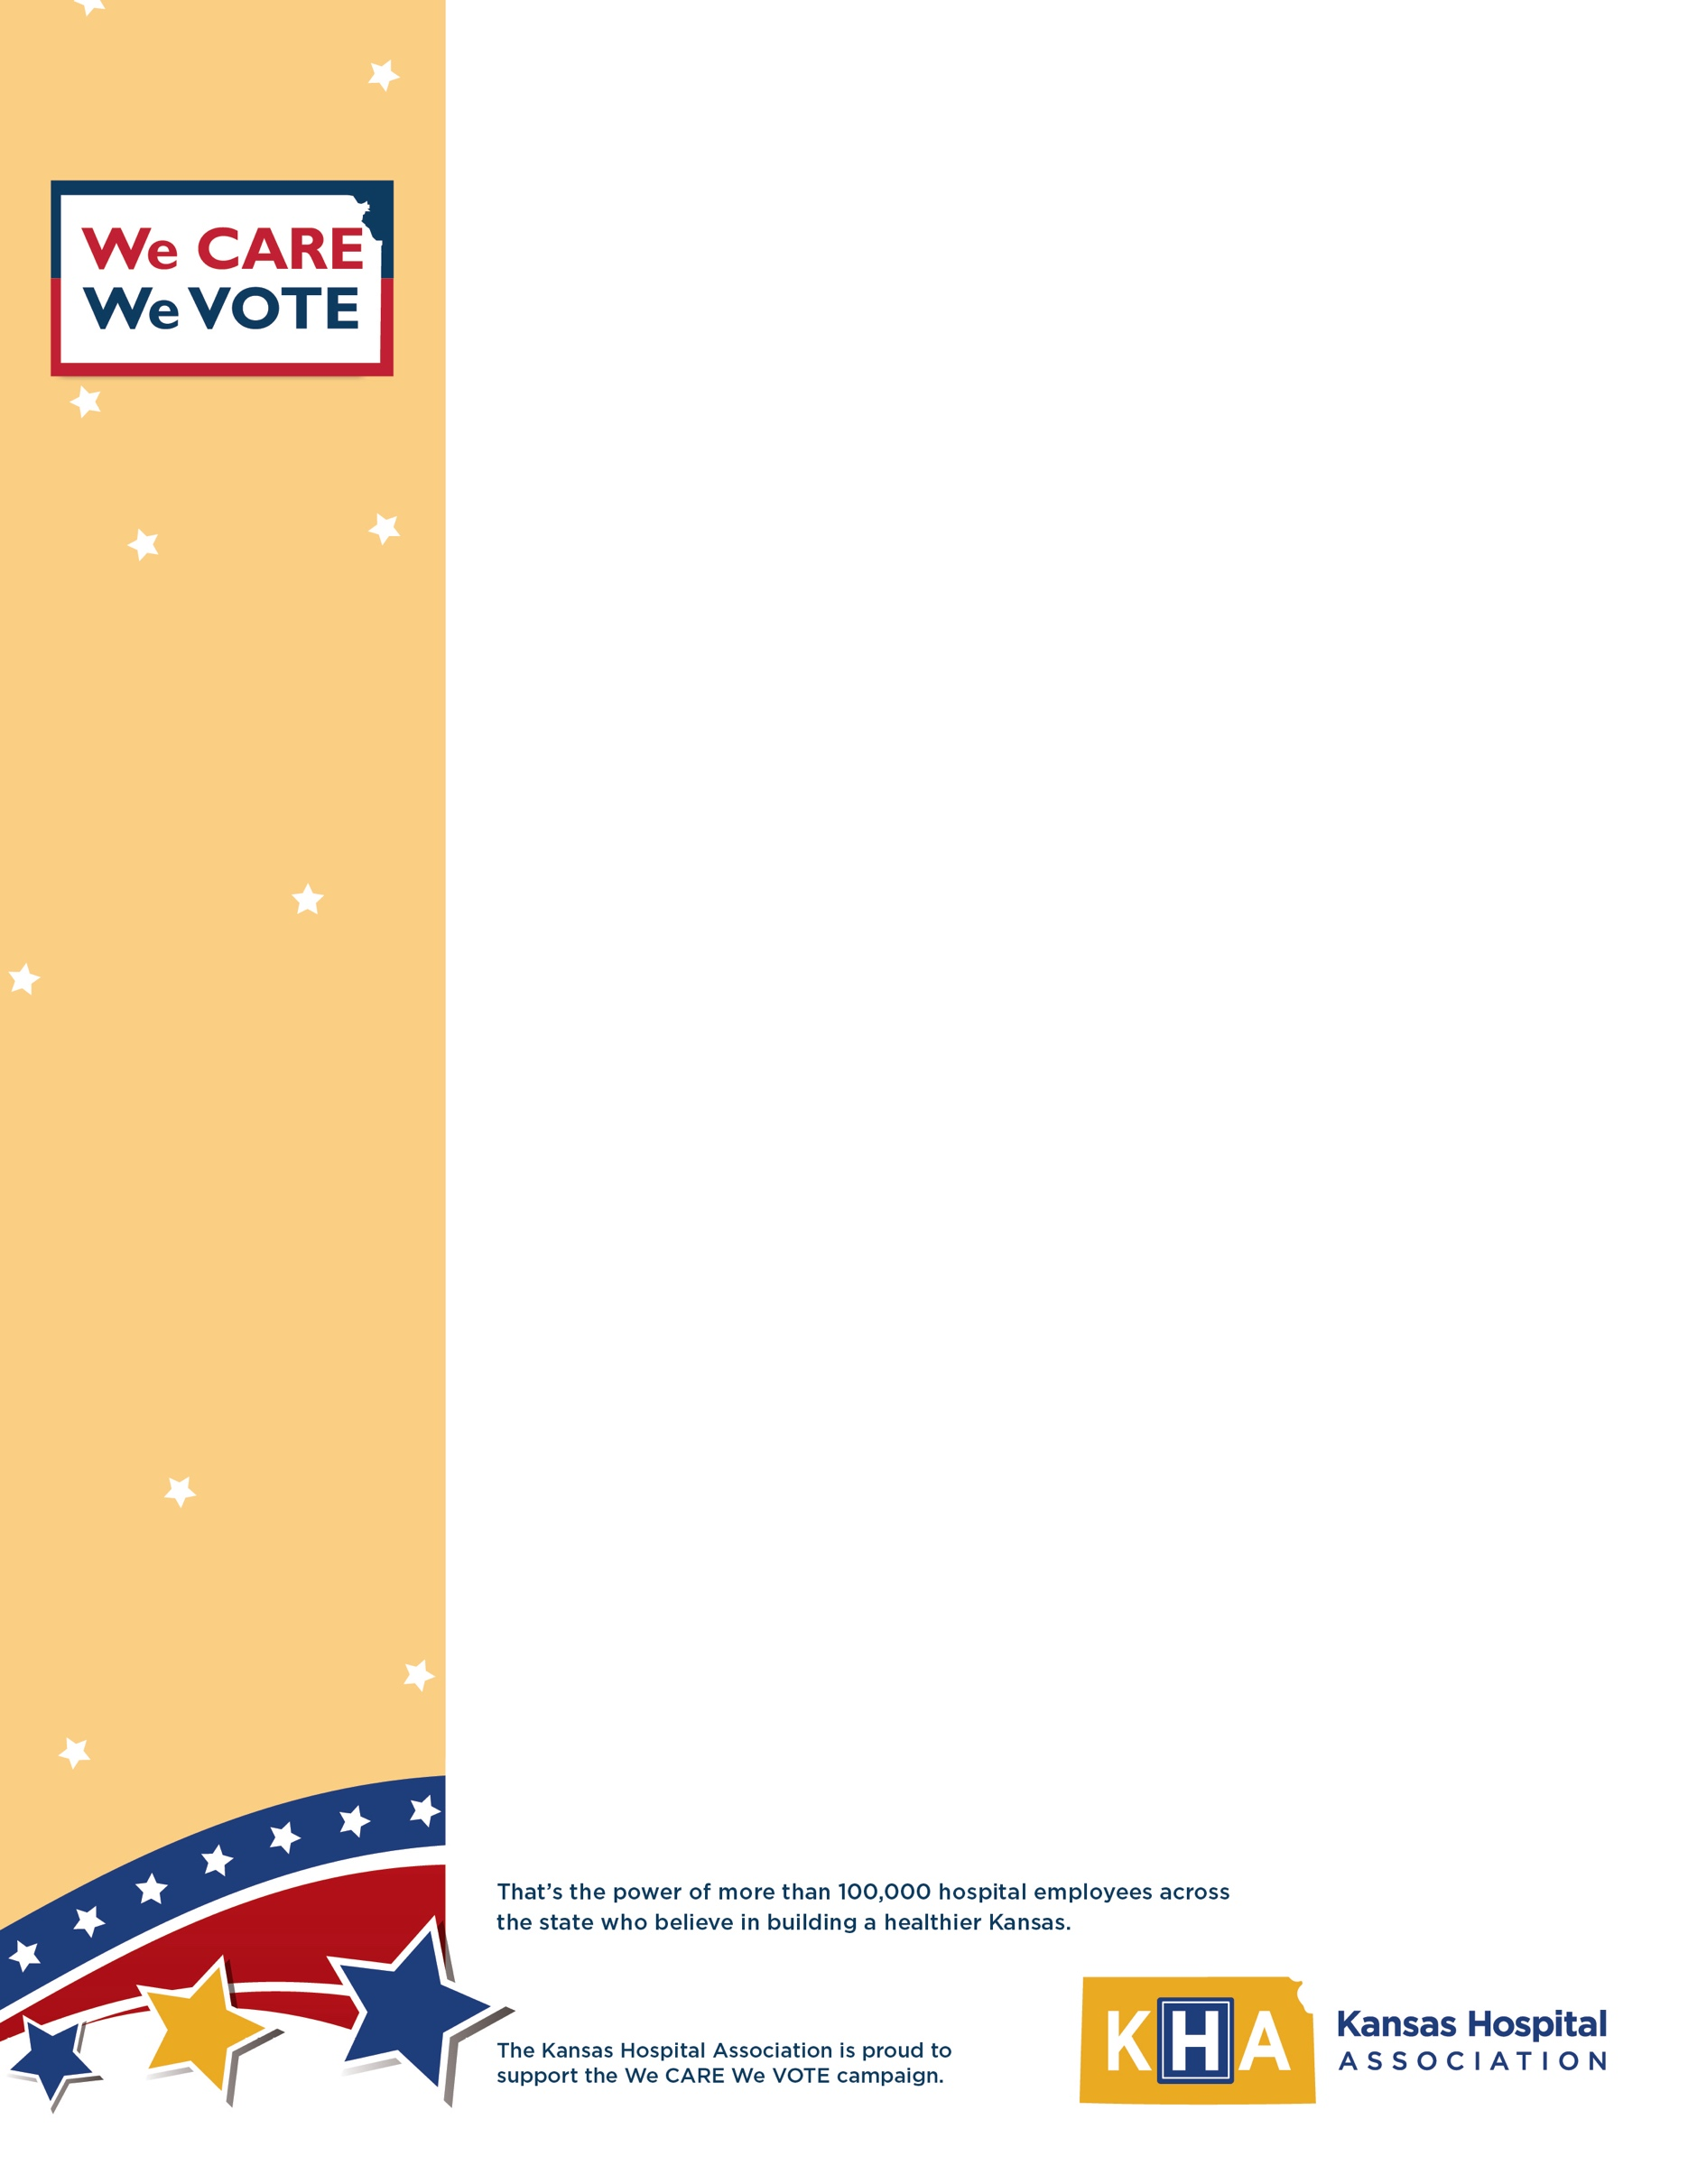
TEMPLATE MEDIA RELEASE

For more information:
For Immediate Release
[Media Contact Name]
[Media Contact Number]

‘We CARE We VOTE’ Initiative Launches at [Hospital Name]

[CITY, STATE] (Date) — As the road to the 2024 election narrows, many voters are thinking about which leaders will work to protect Kansas hospitals and the communities they serve. Among them, of course, are thousands of Kansas hospital employees.

Kansas hospitals employ more than 100,000 people. That represents a significant number of potential votes from people with both professional and personal interests in building a healthier Kansas. Knowing this, [Hospital Name] has launched a “We CARE We VOTE” campaign to engage its employees in connecting the issues to the candidates and casting informed votes in 2024.

“Health care is more than patient-provider interaction – it is also a major economic driver in Kansas, and the financial health of Kansas hospitals has an impact on everyone,” said Chad Austin, president and CEO of the Kansas Hospital Association. Kansas hospitals have an annual direct labor income of more than $6 billion and generate more than $309 million in sales tax. Although hospitals generate a lot of revenue for the state, many are still vulnerable to closure as they struggle with financial insecurity caused by rising costs of care coupled with declining reimbursements.

Austin commends [Hospital Name] for rallying its team with the We CARE We VOTE campaign ahead of the Primary Election on Aug. 6 and the General Election on Nov. 5. The campaign’s message is one of learning and advocacy, inspiring hospital employees to register to vote and in turn use their votes and voices to protect health care access, invest in Kansas communities and hospitals, and strengthen state and local economies.

[INSERT QUOTE HERE FROM HOSPITAL CEO IF DESIRED.]

About [Hospital Name]

[HOSPITAL BOILERPLATE]

